**Hey’s Store Analysis**

**Introduction**

This report contains an analysis of data from a supermarket called Hey’s Store. This supermarket aims to maintain strong sales and continuous customer satisfaction. This analysis covers the various factors that influence the store’s performance, and contains the insights that can drive sales improvements and customer retention.

**Objectives**

this analysis aims to:

1. Provide valuable insights that will in turn lead to a growth in the current customer count increase sales
2. Know the performance of each product line at different branches
3. Know the peak time of the day when more sales are made
4. Know if sales are increasing or decreasing overtime
5. Know their customer demographics and which patronizes them more
6. Know which product line gathers more sales
7. Know which mode of payment customers tend to use more
8. Know which customer type generates more sales
9. Know which customer type generates better ratings

**Data Source**

The dataset used in this analysis was gotten from Kaggle

**Data Cleaning**

The dataset was relatively clean. Just little adjustments were made. Duplicates were removed and necessary and related columns were adjusted to their appropriate formats. The data contained no blanks and the dataset was ready for analysis

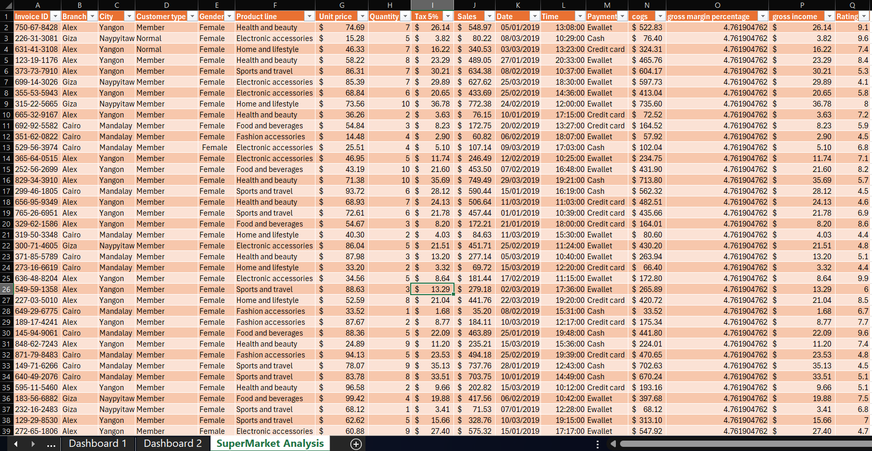

**Analysis**

The analysis was done in Microsoft Excel, using several pivot tables to get insights. The question guiding this analysis are as follows:

* Which product line gathers the most sales?
* Which mode of payment is most preferred by customers?
* Which customer type generates the most ratings?
* Which customer type generates more sales?
* At each branch, which product line generates the most sales?
* What time of day shows larger sales generation?
* Which gender tends to buy more?
* Are sales increasing or decreasing over time?

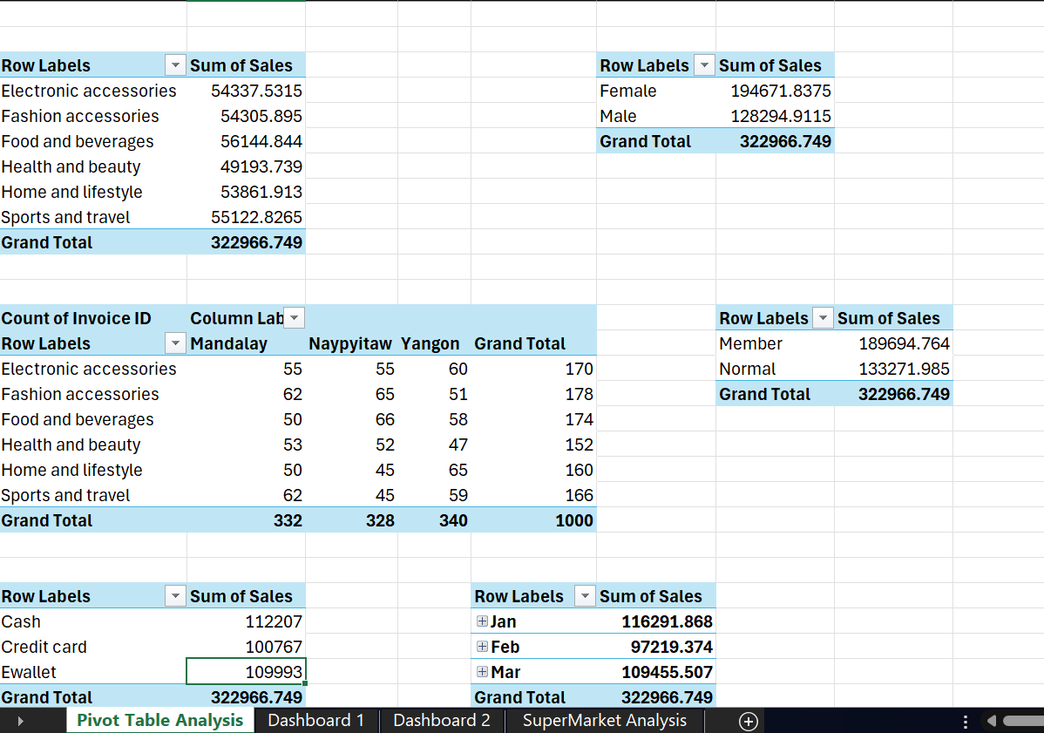

**Visualization**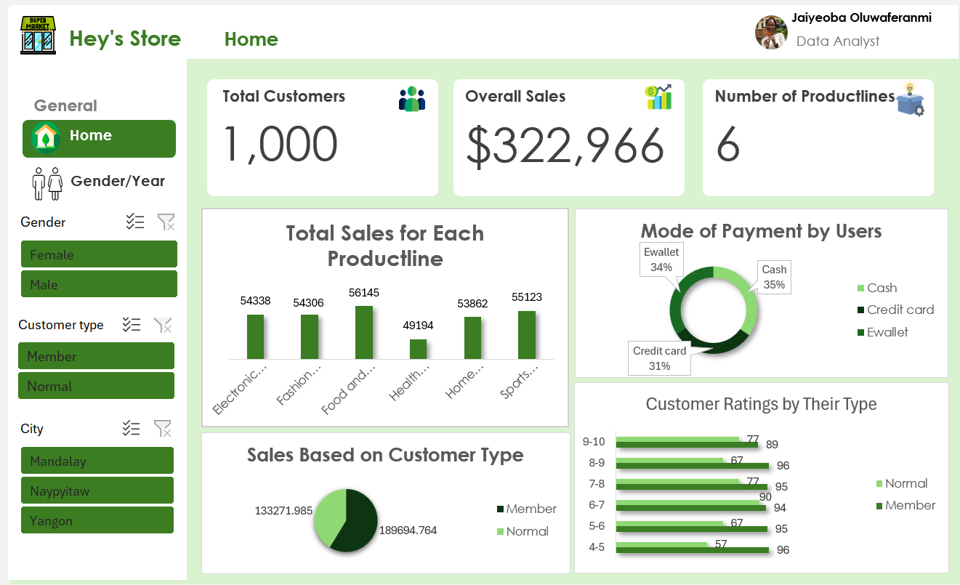

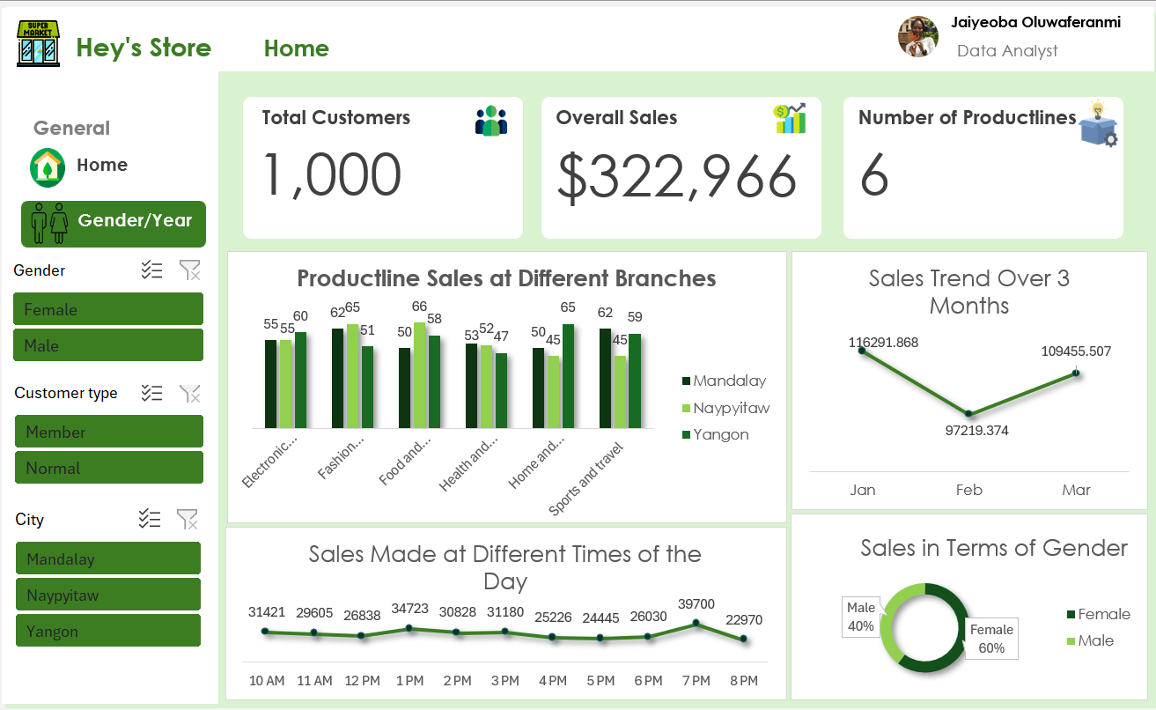

**Insights**

1. **Which product line gathers the most sales?**

From the analysis done in the dataset, the Food and Beverages Product line generated more sales ($56,145) than the others. The next one was Sports and Travel with a total of $55,123. The next ones were electronic accessories ($54,338), Fashion accessories9($54,308), Home and Lifestyle ($53,862), and Health and Beauty ($49,194).

1. **What mode of payment was used by the customers**

The cash mode was the most used amassing to a total of $112,207. Then next was Ewallet which generated $109,993, after which we have Credit card with a total of $100,767.

1. **Which customer type generated more ratings**

Generally, for all the rating categories, the Member customers voted more than the Normal customers. This may be correlated to the fact that there are more Member customers than Normal customers. The normal customers voted in most for ratings between 6 – 7. The highest voted in for member customers is 4 – 5, and 8 – 9 with 96 in both places.

1. **What customer type generates more sales?**

The Member customer category generated more sales with a total of $189,695, while the normal customer category generated a total of $133,272. The member customers generated undoubtedly more of the total sales made.

1. **At each branch, what product line generates more sales?**

In the Electronic Accessories, Yangon had the highest which was a total of 60 people. (Mandalay (55), Naypyitaw (55)), in Fashion Accessories, the highest was Naypyitaw with a total of 65 (Mandalay (62), Yangon (51)), in Food and Beverages, the highest was Naypyitaw with a total of 66 (Mandalay (50), Yangon (58)), in Health and Beauty, the highest was Mandalay with 53 people (Naypyitaw (52), Yangon (47)). In Home and Lifestyle, the highest was Yangon with 65 people (Mandalay (50), Naypyitaw (45)). In Sports and Travel, the highest was Mandalay with a total of (Naypyitaw (45), Yangon (59)).

1. **What time of the day shows larger sales generation?**

The time of the day with the highest sales is recorded to be 7 pm, which amassed a total of $39,700. The next one is 1 pm with a total of $34,723.

1. **Which gender tends to buy more?**

The female gender bought more as the total sales generated for females is $194,672, while for males is $128,295.

1. **Are sales increasing or decreasing overtime**

This analysis shows that the sales made in February dipped compared to other months. However, March shows that the company put in a lot of effort to boost sales and regain momentum.

**Recommendations**

* **Targeted Marketing:** the Food and Beverages, and Sports and Travel product lines should be focus marketed, since these product lines have the highest sales.
* **Optimize Payment Options:** Ewallet and Credit card aren’t as often used as Cash, but increasing their convenience and availability will also increase the customer’s experience.
* **Member Program Enhancement:** Since ‘Member’ customers generate more sales and provide higher ratings, enhancing the joining of membership program could further increase engagement and satisfaction.
* **Gender-Specific Campaigns:** Tailored promotions to Female Customers will help to boost sales as they contribute significantly to the sales figure.
* **Maximizing Branch Specific Product Lines:** Leveraging on the strengths of each branch would help to maximize performance and sales e.g. promoting specific product lines based on branch success.

**Conclusion**

This analysis provides key insights into various factors in the Hey’s Store, such as customer behaviour, product performance, and sales trends. By acting on these insights, Hey’s Store can optimize operations, increase sales, and enhance customer satisfaction.